EB308R
Installation Instructions for IO Expansion Card
- Product Confirmation

EB308R board | M3 Screw
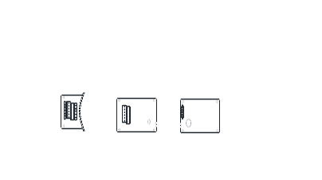 | 

- Component Name
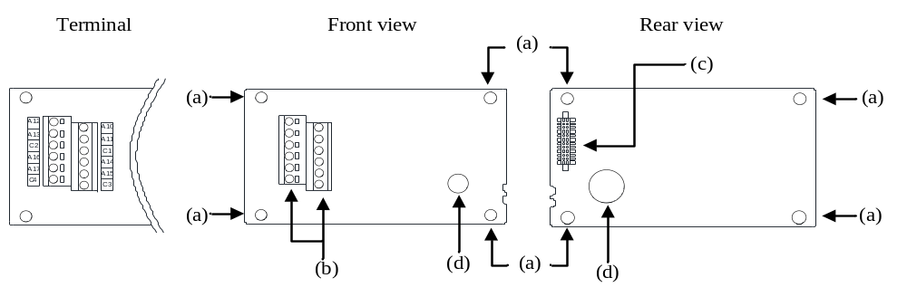

No. | Name | Instructions
a | Mounting hole | Use M3 screw to install the EB308R board to the inverter
b | Terminal | Connect wiring for customer
c | Connector | Connect to the inverter
d | Plastic handle | Remove EB308 board

- Electrical Specifications

Terminal form | Terminal name | Function instructions | Terminal specification
Relay outputs | A10, C1 | Multi-function relay outputs 8 groups;  A-C is the normally open contact. | Maximum voltage: 30VDC or 250VAC  Maximum current: Resistive load:5A NO  Inductive load: 2A NO  (cosΦ=0.4)
Relay outputs | A11, C1
Relay outputs | A12, C2
Relay outputs | A13, C2
Relay outputs | A14, C3
Relay outputs | A15, C3
Relay outputs | A16, C4
Relay outputs | A17, C4

- Wiring Schematic Diagram
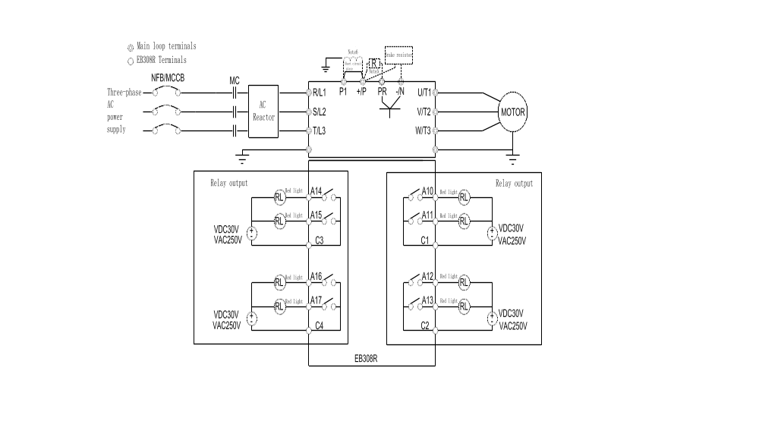

- Installation(SA3)
Step1: As the Figure 1 shows, please insert EB308R into the control board SLOT 2 or SLOT 3, not SLOT 1.
Step2: Please lock the two M3 screws with screwdriver according to the torque of 4-6kgf.cm and the direction showed in
Figure 2.
Note: When removing EB308R board, please first remove the right and left M3 screws, and then lift the plastic handle by hand.
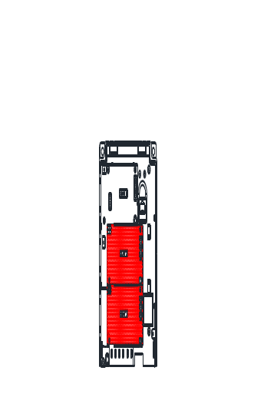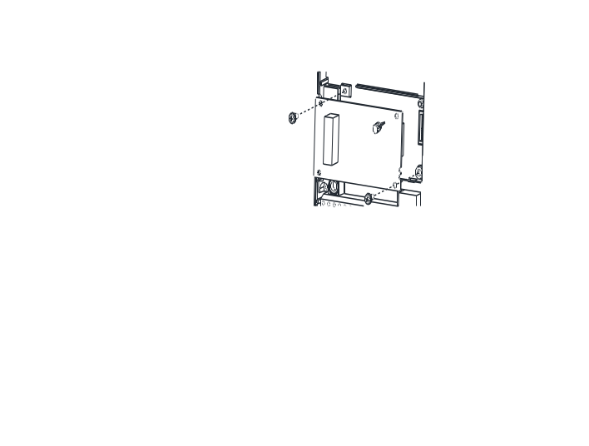
Figure 1 Figure 2

- Installation (SE3)
Step 1：Turn off the power.
Step 2：Open the top coverof the inverter.
Step 3：Use the front rear as support and slide (a) in by pressing down as figure 1 shown.
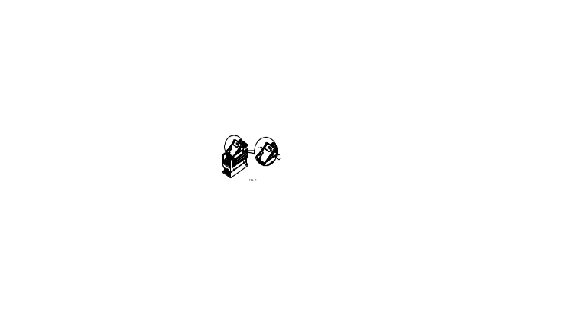
Figure 1
Note: (a)-Optional Card Housing; (b)-Hook, (c)-Slot
Step 4: Line up the connector (c) and (d), and press down the EB308R expansion card to the right position.
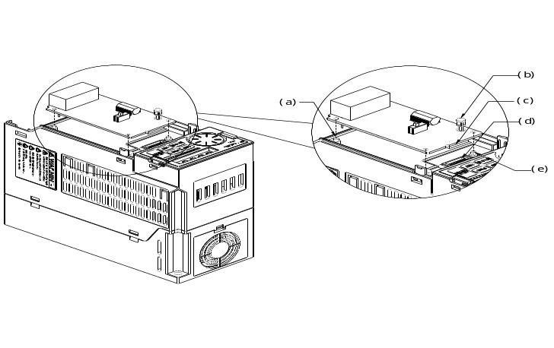
Figure 2
（a）(e)-Supporter, (b)-Plastic Handle, (c)-Male connector, (d)-Female connector
Step 5: Tighten two M3 screws with 4-6kgf.cm torque on the card. Install the cover after wiring.
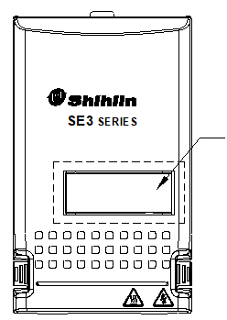
Need Cutout this area for installating the cover
Figure 3 Figure 4

- Others
To improve our products, the parameters and contents may be modified, please contact the agent or refer to Shihlin websites
(http://automation.seec.com.tw/) to download the latest version.



